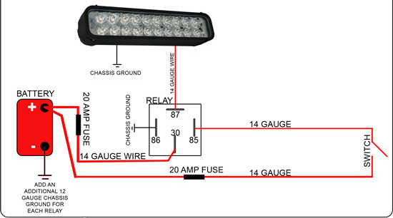
Mounting –

First mount the light bar in a desired location, then, keep the bottom base nuts snug but don’t tighten. Adjust the bar so that it is centered on the off road machine. Tighten the bolt on the bottom of the bracket to 20 ft/lbs. Mounting tabs should be placed 3.5” in from each end and then 12” from there.

Wiring –

Mount the switch provided in the harness, (if you have your own switch it’s OK to use) now carefully route the harness from the mounted switch to the battery and then to the LED bar wire harness connector. Test the light at this time.

Adjust light –

Adjust the light to the desired horizontal height, then use the supplied Allen wrench to tighten both side Allen bolts on each end. A good reference point is at 20 ft; the top of the beam should be 3” down from center of light (with the light bar at dead center). Tighten light and enjoy.

Custom Wiring (optional) –

All electronics are internal so there is no need to mount external electronics. Each light has a simple 2 wire hook up. Red being + 12v and black being – 12v. Lights should be wired to a switch through a relay with a maximum of 2 lights per relay, up to 12” bars, and 1 light per relay for larger, for optimum durability and performance. Each relay should be wired as follows:

86 – chassis ground
85 – 12v + trigger from switch
30 – 14 gauge 12+ from battery (minimum gauge is 14 for 2 lights)
87 – 14 gauge out to red (or white for 6504) wire on lights (max 2 lights per relay pack)

Duplicate relay packs can be wired for additional lights. Switch trigger can be jumped from relay to relay.

Remaining black wire on light should be chassis grounded or grounded to the negative terminal of the battery; making sure grounding surface is cleaned down to metal, using a stainless steel bolt to secure grounding ring.

